Coffee Sales data Analysis MySQL Syntax
KPI’s
- Total Revenue
SELECT sum(money) AS Total_Revenue FROM coffe;
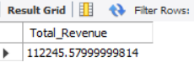
- Average Order Value
SELECT SUM(Money)/COUNT(order_id) as avg_order_value FROM coffe;
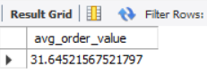
- Total Orders
SELECT COUNT(DISTINCT order_id) AS Total_orders FROM coffe;
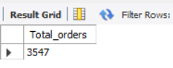

Charts Requirement
- Daily trend for total orders:
SELECT DISTINCT Weekday AS Day ,
COUNT(order_id) AS Number_of_orders
FROM coffe
GROUP BY Day;
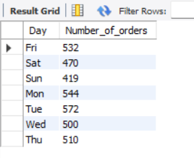
- Monthly trend for total orders:
SELECT DISTINCT Month_name AS Month,
COUNT(Order_id) AS Total_orders
FROM coffe
GROUP BY Month;
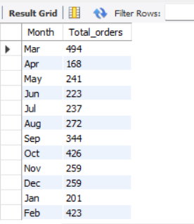

- Percentage of sales by coffee type:
SELECT coffee_name,
(SUM(money)) AS Revenue,
(SUM(money))*100/(SELECT SUM(money) FROM coffe) AS percentage
FROM coffe
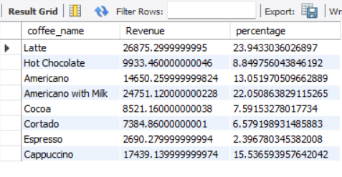
4. Day Trend for total orders:
SELECT Time_of_day,
COUNT(order_id) AS number_of_orders
FROM coffe
GROUP BY Time_of_day;
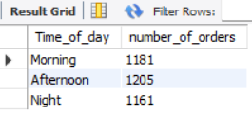
5.Top 3 coffee by revenue
SELECT coffee_name,
SUM(money) AS Revenue
FROM coffe
GROUP BY coffee_name
ORDER BY Revenue ASC LIMIT 3;
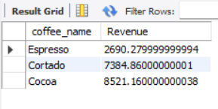
6.Bottom 3 coffee by revenue
SELECT coffee_name,
SUM(money) AS Revenue
FROM coffe
GROUP BY coffee_name
ORDER BY Revenue DESC LIMIT 3;
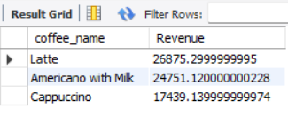
7.Top 3 coffee by quantity
SELECT coffee_name,
COUNT(order_id) AS number_of_orders
FROM coffe
GROUP BY coffee_name
ORDER BY number_of_orders ASC LIMIT 3;
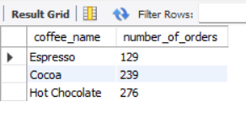
8.Bottom 3 coffee by quantity
SELECT coffee_name,
COUNT(order_id) AS number_of_orders
FROM coffe
GROUP BY coffee_name
ORDER BY number_of_orders DESC LIMIT 3;
